
英文法: 只是一些規則而已
The Grammar Rules of Thumb
www.amstarcreative.com


第3章 名詞 (聽力練習)
Brian Regan Talk Show on Spelling Bee
Activity 1: Warm up questions
1. What is Spelling Bee?
National Spelling Bee competition: http://www.youtube.com/watch?v=VjzrNWPul9E

2. Why do you think American children play this “game” at young age?

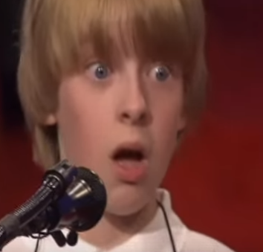
3. Do you think children enjoy this game? Why or why not?
Funny video 1: http://www.youtube.com/watch?v=nfWUhCL0A-I
Funny video 2: http://www.youtube.com/watch?v=bGdCeMayUjk&NR=1

4. After watching the videos, do you think this is a hard game? Why or why not?

Activity 2: Listen
Listen to Brian Regan do a standup comedy show on the topic “Spelling Bee”. Fill in the blanks. http://www.amstarcreative.com/eng/conversation/talkshow/talkshow_1.html

I’d be a lot better off if I (1) _____________ studied more when I was growing up, you know.
But you know where it all went (2) ___________ was the day they started the Spelling (3) ___________.
Cuz up until that day I was an (4) ________ but nobody else knew, you know. The Spelling Bee day (5) ___________ up. Alright (6) _________ up against the wall, it’s time for public (7) ________________. Spell a word wrong and (8) ___________ down in front of your friends. You know that’s great for little (9) _________. Hey, look at me I’m a moron. I wasn’t even close. I was using (10) ____________ and stuff. That’s why I (11) ____________ that kid who spelled the word wrong on purpose so he could sit down, you know. He (12) __________ he wasn’t going to win so why stand there for (13) _____________ hours. First round, cat. K-A-T. I’m (14) __________ here. And as he (15) ________ you, HAHA “I know there’s two Ts”
I remember my teacher asked me, “Brian what’s the “i” before “e” rule?”
UM, i before e, always. What are you an idiot Brian? Apparently
So she explained, “no Brian, it’s i before e, except after c and when sounding like “ai” as in neighbor and weigh and on weekends and holidays and all throughout May, and you’ll always be (16)________ no matter what you say. That’s a hard rule. That’s a (17) _____________ rule.

(18) ____________ were hard too. Brian how do you make a word a plural?
Um, you put a“s”. You put a“s” at the end of it. When? On weekends and holidays.
No Brian no, let me show you. So she asks this (19) _______ who knew everything, Arwin.
Arwin, what is the plural of ox? Oxen, the farmer used his (20) ___________.
Brian. What? What’s plural of box? Boxen. I bought two boxen of (21) __________________.
No Brian, no. Let’s try another one. Arwin, what is the plural of goose. (22)_____________. I saw a flock of geese. Brian. What? Brian, what’s the plural of moose? (23) ___________. I saw a (24) _________ of moosen. There many of them, many much moosen. Out in the woods and the woodes, and the woodesen. The meese wanted the food. Food is to eatnesen. The meesewantin the food in the woodingenesen.The food in the woodenesen.
Brian. Brian. You’re an (25) _____________. Imbeciline. What are you speaking German, Brian?
German, Jermaine. Jermaine, Jackson. Jackson five chino. Brian, what the hell are you talking about?
I don’t know. I don’t know really.

Activity 3: Learning
- What new vocabulary/phrases/grammar rules did you learn?
- What new culture did you learn?
- What was the funniest part of this video?

